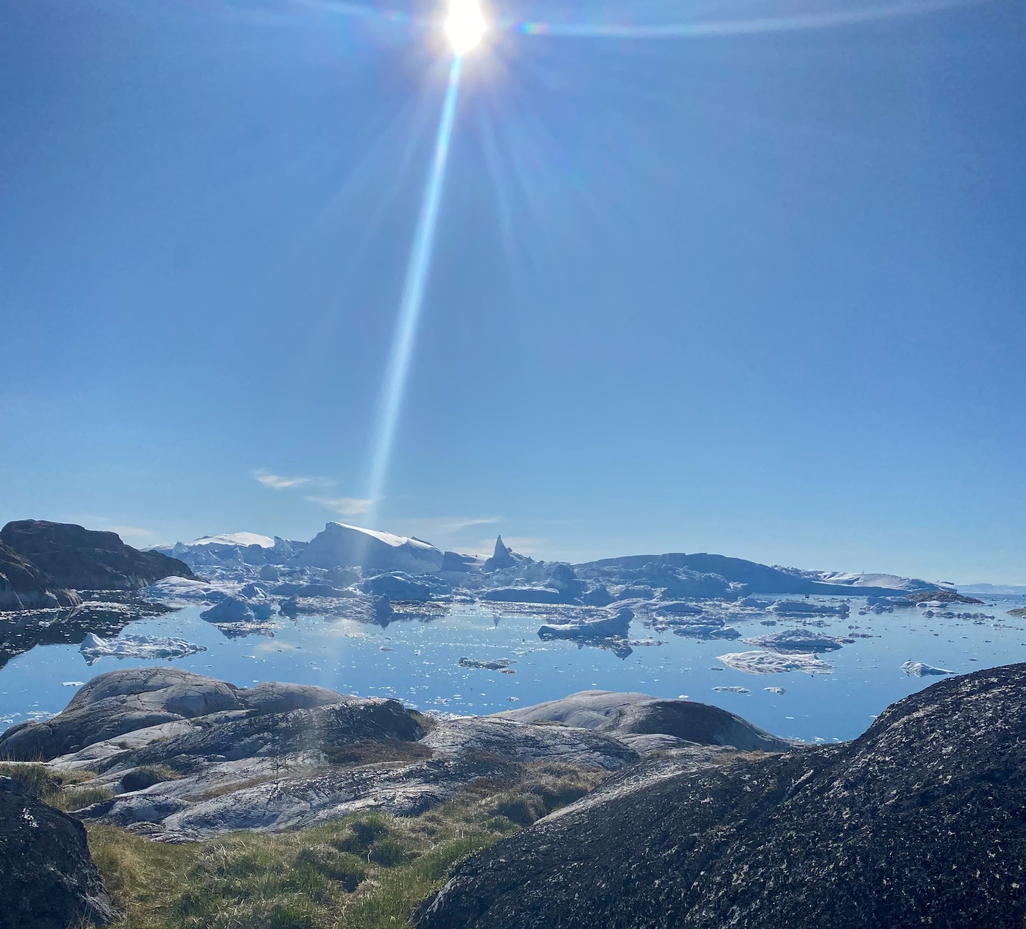

ARCTIC PARLIAMENTARIAN SUMMIT
Programme
September 11-13 2022
Hotel Hans Egede, Nuuk

Nordic and North-American Collaboration

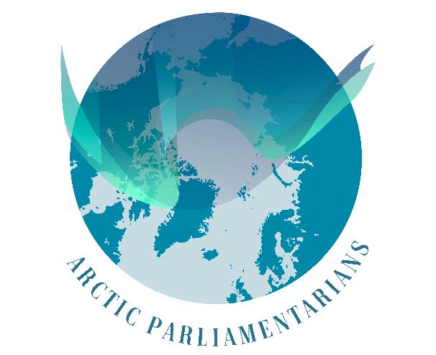
SUNDAY, SEPTEMBER 11
12.00-13.00 Lunch
Venue: Restaurant Gertrud Rask, Hotel Hans Egede

13.00 Participant registration. Information desk available
Venue: Foyer, Hotel Hans Egede

14.00 Welcoming remarks by Chair Aaja Chemnitz
Venue: Konference no. K20/22

14.15–15.00 Kick-start Debate One
Arctic Democracy
Venue: Konference no. K20/22
Moderator: Ms. Sara Olsvig, International Chair ICC

Arctic Women Leadership
Venue: Konference no. K12
Moderator: Chair Mrs. Aaja Chemnitz

15.15–16.00 Kick-start Debate Two
Arctic Film and Media
Venue: Konference no. K20/22
Moderator: Dr. Klaus Georg Hansen, Film.gl
Arctic Law
Venue: Konference no. K12
Moderator: Lawyer Thor Suhr, Nunatsinni Advokatit, International association for Greenlandic lawyers.

16.30–18.00 “Kaffemik”
Public traditional Greenlandic cake-event with live music
Venue: Katersortarfik / Nuuk Community centre –
see map for directions

18.30–21.00 Buffet reception at Hans Egede
Venue: Restaurant Gertrud Rask, Hotel Hans Egede

MONDAY, SEPTEMBER 12
07.30 Participant registration. Information desk available
Venue: Foyer, Hotel Hans Egede

09.00 Official opening of the Arctic Parliamentarian Summit
Mrs. Aaja Chemnitz, Chair
Mr. Múte B. Egede, Prime Minister Greenland (video speech)
Ms. Avaaraq B. Olsen, Mayor, Kommuneqarfik Sermersooq (video speech)
Mr. Jeppe Kofod, Minister of Foreign Affairs, Denmark (video speech)
Ms. Sara Olsvig, International Chair ICC
Venue: Konference no. K20/22

09.25 FIRST SESSION
Peoples of the Arctic
Moderator: Ms. Lori Idlout, Member of Parliament for Nunavut.
Venue: Konference no. K20/22

Mr. Håkan Jonsson, President of the Sami Parliamentary Council and board
chairman of the Sami Parliament in Sweden

Ms. ArnâraK’ Patricia Bloch, Researcher, Center for Public Health in Greenland

10.45 Short break

11.00–12.30 SECOND SESSION
Climate change in the Arctic
Moderator: Mrs. Yvonne Jones, MP, Canada
Venue: Konference no. K20/22
Mr. Lars Haltbrekken, MP, Norway
Dr. Professor Minik Rosing, University of Copenhagen

12.30–13.30 Lunch
Venue: Restaurant Gertrud Rask, Hotel Hans Egede

13.30–14.15 BREAKOUT SESSIONS – FIRST ROUND
The Economy in the Arctic
Venue: Konference no. K20/22
Moderator: Mr. Mads Qvist Frederiksen, Arctic Economic Council
The Future of the Arctic
Venue: Konference no. K12
Moderator: Ms. Aviaaja Egede Lynge, National Children’s Council
14.25–15.10 BREAKOUT SESSIONS – SECOND ROUND
Research and Science in the Arctic
Venue: Konference no. K20/22
Moderator: Dr. Anna-Sofie Skjervedal, Arctic International Hub

Mental Health in The Arctic
Venue: Konference no. K12
Moderator: Ms. ArnâraK’ Patricia Bloch, Researcher, Center for Public Health in Greenland
Ms. Lineik Anna Sævarsdóttir, MP, Iceland

15.10–15.25 Short break

15.40–16.30 THIRD SESSION
Economic sustainability in the Arctic
Moderator: Mr. Mikko Kärnä, MP, Finland
Venue: Konference no. K20/22
Ms. Aaja Chemnitz, Chair, Arctic Parliamentarians
Mr. Mads Qvist Frederiksen, Director, Arctic Economic Council
Mr. Karsten Høy, CEO, Greenland Holding

18.30–21.00 Official Summit Dinner with live music
Venue: Restaurant Gertrud Rask
Remarks from
Chair Ms. Aaja Chemnitz
Ms. Sara Olsvig, International Chair ICC
TUESDAY, SEPTEMBER 13
Excursion Day
Boat trip to Qooqqut
Go with us on this boat-trip (appr. 2 hour each way + time spent there) where you will get the opportunity to fish and eat your catch afterwards in beautiful surroundings on the lovely restaurant Nuan’ in Qooqqut.

Local tour in Nuuk
If you prefer to stay on ground, the organizer welcomes you on a 4-hour cultural excursion, where you will enjoy a city walk in Nuuk and visit local and national museums. A unique opportunity to get to know more about Greenland and the capital Nuuk with a local guide.
Practical information
Venue Hotel Hans Egede, Nuuk

Registration Sunday 11 June: 13.00–16.00
Monday 12 June: 07.30–17.00

Entrance Aqqusinersuaq 1, 3900 Nuuk

Plenary Konference no. K20/22 Floor, Hotel Hans Egede

Security There will be a security check upon arrival at the Summit.
Please be prepared to show your ID.

Badge All participants will receive a badge at the registration desk. Please wear the badge visibly at all meetings and activities. There are three different categories:
Member Red
Secretariat Green
Guest Yellow

Wifi Is available at the conference center.

Information There is an information desk situated at the hotel reception,
desk where it is possible to print documents. For larger printing
jobs, please contact the Secretariat.

Interpretation There will be interpretation between English and Greenlandic at the main venue K20/22.

Transportation Participants are transported from Nuuk Airport to Hotel Hans
Egede upon arrival. Participants that arrives on Sept 12 or 13
are kindly requested to organize their own transportation.
The taxi journey between the airport and the Hotel Hans
Egede takes around 15 minutes.
The airport taxis accept credit cards.

Excursion Tuesday 13 Sept 09.00–20.00 Boat trip to Qooqqut
Dress code: Casual/Warm. Comfortable shoes.

Dinner Sunday 11 Sept Dinner reception at Hotel Hans Egede
Meeting point: the main entrance at Hotel Hans Egede.
Please bring your ID.
Dress code: Business wear/Informal.

Airport Transport Buses leave Nuuk Airport 11.30, 12.00 and 12.30
Saturday 10 Sept to Hotel Hans Egede

Dinner Monday 12 Sept 18.30–21.00 Official dinner at Katuaq hosted by the Chair of
Arctic Parliamentarians. Please wear your badge.
Dress code: Business wear/Informal.

Airport transport Buses leave Hotel Hans Egede 6.00, 6.30, 7.00
Wednesday 14 Sept and 7.30 to Nuuk Airport

Emergency numbers +299 112 (in case of fire or injury)
Nuuk +299 70 14 48 (Police)

Nuuk Taxa +299 36 36 36

Secretariat Peder H. Pedersen +45 6162 3007
Morten Schiøttz +45 3337 3084
Dennis B. Sichlau +45 6162 3868
Iluuna Heilmann +45 6162 4008
Lilli Skifte +45 6162 4043

Smoking Smoking is allowed in designated areas in
Hotel Hans Egede.

