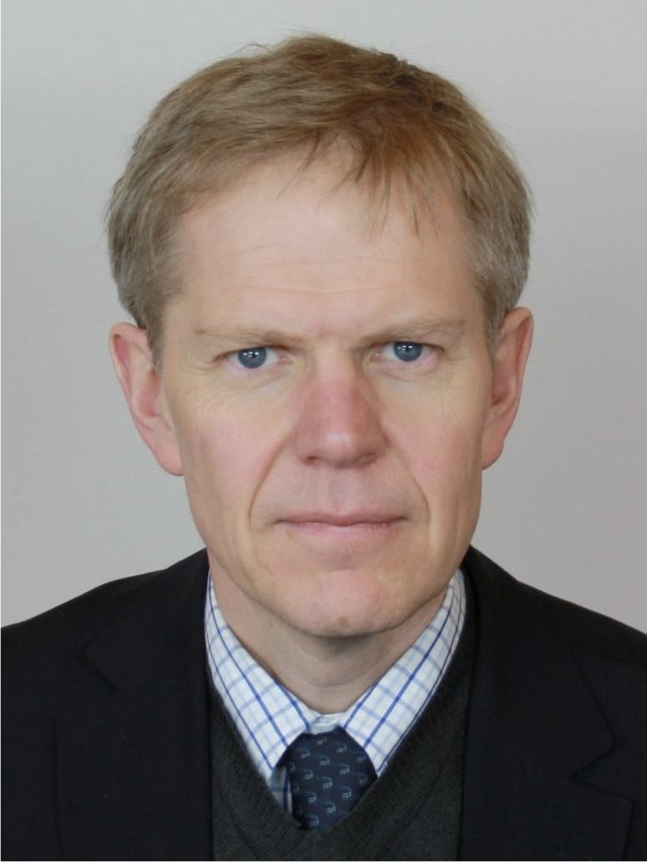

On September 1, 2017, Björn Lyrvall assumed the position of Swedish Ambassador for Arctic Affairs.

From 2013 to 2017 he served as Ambassador of Sweden to the United States of America and prior to this, between 2007 and 2013 Ambassador Lyrvall was Director General for Political Affairs at the Ministry for Foreign Affairs in Stockholm.

From 2002 to 2007, Ambassador Lyrvall was posted at the Swedish Permanent Representation to the European Union in Brussels, first as Swedish delegate to the enlargement negotiations (2002-2003), and then Swedish Ambassador to the EU Political and Security Committee (2003-2007).

Ambassador Lyrvall has also been working as Special Advisor to former Prime Minister Carl Bildt in his capacities as EU negotiator and International High Representative in Bosnia and Hercegovina (1995-1997), as well as UN Special Envoy on the Balkans in 1999.

Additional diplomatic posts include Leningrad, Moscow and London.

Born in Hofors, Sweden, in 1960, Björn Lyrvall is a graduate of the University of Stockholm, and holds a degree in political science, Eastern European Affairs and Russian.

Björn Lyrvall is married and has three children.

Björn Lyrvall
Phone: +46-70-3083237
Email: bjorn.lyrvall@gov.se
Twitter: @bjornly

