

**Document 1.2**

CONFERENCE OF PARLIAMENTARIANS OF THE ARCTIC REGION

THE STANDING COMMITTEE OF PARLIAMENTARIANS OF THE ARCTIC REGION

**MEETING IN BODØ**

24 May 2016

Venue: Hotel Scandic Havet, Bodø

Room: “Refleksjon”

**DRAFT ANNOTATED AGENDA**

1. **ADOPTION OF THE AGENDA AND THE PROPOSED ORDER OF AGENDA**

**ITEMS**

Enclosed:

1.0 Draft program SCPAR meeting in Bodø, 24 May 2016

1.1 Draft agenda, SCPAR meeting in Bodø, 24 May 2016

1.2 Draft annotated agenda, SCPAR meeting in Bodø, 24 May 2016

1.3 Draft list of participants, SCPAR meeting in Bodø, 24 May 2016

Decision proposal:

The Committee adopts the agenda and the proposed order of agenda items for the SCPAR meeting.

1. **APPROVAL OF DRAFT MINUTES FROM THE SCPAR-MEETING IN**

**STOCKHOLM, 3 MARCH 2015**

Enclosed:

2.1 Draft minutes and list of participants from the SCPAR-meeting in in Stockholm 3 March 2016.

Decision proposal:

The Committee approves the minutes from the SCPAR-meeting in Stockholm 3 March 2016

1. **PRESENTATION FROM THE NORWEGIAN JOINT HEADQUARTERS**

Security in the Arctic

Military issues are not a part of the Arctic Council cooperation. The Ottawa-declaration from 1996 which is the basis for the Arctic Council cooperation specifically excludes military issues from the cooperation.

Security issues have however been prominent on the Arctic agenda. Search and rescue at sea, environmental security and human security in the face of climate change are all important topics on the agenda of the Arctic cooperation.

The establishment of the Arctic Coastguard Forum in October 2015 was an important step forward to improve future cooperation on Search and Rescue in the Arctic. Joint search and rescue exercises are being held to implement the agreement from 2011 between the Arctic countries.

The disagreement over the situation on Crimea and Eastern Ukraine has put a stop to most of the military cooperation between Russia and the other Arctic countries. In advance of the change in the current situation, the Chiefs of defense and high level representatives from all eight Arctic states met at a Canadian military base in Goose Bay 12-13 April 2012 to discuss challenges each faces with regards to emergency response and for support to civilian authorities.

The Norwegian Joint Headquarters

The Norwegian Joint Headquarters (NJHQ) operates day and night, and has the overall command and control of all military activity in Norway. It also commands the Norwegian military personnel abroad. In Norway, it controls activities like the Coast Guard, the search and rescue service, military air traffic, and the Border Guard.

The Headquarters operates from its mountain complex outside the city of Bodø in Northern Norway. From its operation centre, officers continuously monitor the activity in Norway's vast land and sea territories.

NJHQ m​ain tasks:

* ​Keep an eye with Norway's vast sea and air territories, and have a current understanding of the overall situation.
* Exercise sovereignty in Norway's land, sea and air territories – and exercise national jurisdiction in these areas.
* Be present, and be able to handle crisis of any kind.
* Support civil society.
* Plan and head military exercises.
* Provide control and suppo​rt to Norwegian forces in international operations.

Commodore Solveig Krey from the NJHQ will present the activity of the NJHQ which has relevance for the Committee.

Decision proposal:

The Committee takes note of the information.

1. **PREPARATIONS FOR THE CONFERENCE OF PARLIAMENTARIANS OF THE ARCTIC REGION IN RUSSIA 14-16 JUNE 2016**

Enclosed:

4.1 Draft program, Ulan-Ude

4.2 Draft Conference Statement, Ulan Ude, 2nd Draft

4.3 Picture of meeting venue, Ulan-Ude

The 12th Conference of Parliamentarians will take place in Ulan-Ude 14-16 June 2016 with the Russian State Duma as the host of the Conference and works together with the Standing Committee to prepare the program for the conference.

The representative from the State Duma will update the Committee on the progress for the preparations.

The Chair of the Committee will give an update on the work with the draft Conference Statement.

Decision proposal:

The Committee takes note of the information and gives feedback on planning of the Conference.

1. **STATUS OF THE WORK OF SCPAR**
   * Report on Arctic activities by members
   * Report from the secretariat
   * General exchange of view

Enclosed:

5.1 Summary from the Arctic Economic Development Forum

Decision proposal:

The Committee takes note of the information.

1. **NEXT MEETINGS OF SCPAR**

The next meetings of SCPAR will be in Ulan-Ude, 14 June and 16 June 2016 in connection to the 12th Conference of Parliamentarians of the Arctic Region.

The Canadian delegation would like to invite the Committee to meet in Ottawa 14-15 November 2016.

Decision proposal:

The Committee meets in Ulan-Ude 14 and 16 June, and in Ottawa 14-15 November 2016.

1. **ANY OTHER BUSINESS**

**The Committee walks to the offices of the Joint Rescue Coordination Center, Northern Norway**

1. **Visit the Joint Rescue Coordination Center, Northern Norway**

Enclosed:

8.1 Search and Rescue agreement from 2011

1. **Orientation from JRCC**

Norwegian rescue services are carried out through cooperation between government agencies, voluntary organizations and private companies which have resources appropriate for rescue services.

The Joint Rescue Coordination Centres have the overall operational responsibility during search and rescue operations on land and sea. The operations are coordinated either directly from one of two Joint Rescue Coordination Centers (JRCC) which are situated in Bodø and in Sola near Stavanger, or through one of 28 rescue sub centres.

At the JRCC in Bodø there are 22 employees who dealt with 2772 incidents in 2015. These incidents include medical evacuation from ships and offshore installations, search for lost persons, alpine rescue etc.

In addition to the national responsibilities, the regional cooperation is extensive. “Barents Rescue” is a joint biennial exercise between Finland, Norway, Russia and Sweden. Finland hosted the exercise in 2015 and Russia will host the next in 2017. The basis for this cooperation is an agreement between the Governments in the Barents Euro-Arctic Region on Cooperation within the field of Emergency Prevention, Preparedness and Response was signed on 11 December 2008 in Moscow. The Agreement took effect on 17 May 2012 upon ratification by all Parties.

A Barents Joint Rescue Manual has been developed for use in emergency situations as defined by the Agreement and provides guidance and instructions for the implementation of the Agreement.

Norway and Russia conduct joint exercises for marine operations in the Barents Sea.

The Committee will be taken on a guided tour to the operation room of the rescue center.

Director Bent-Ove Jamtli will introduce the Committee to the work of the Joint Rescue Coordination Center, and guide the Committee in the operation room.

1. **Orientation from the Coast Guard**

The Coast Guard in the Arctic countries is the most important tool to conduct search and rescue operations in the Arctic area. A closer cooperation between the Coast Guards is of paramount importance to improve the capacity. The establishment of the Arctic Coast Guard Forum 30 October 2015 was therefore a significant positive development.

The statement from the 11th Conference of Parliamentarians of the Arctic Region in 2014 has an article related to the Coast Guard:

*“Promote closer cooperation among coastguards in the Arctic countries and work towards getting a common operational picture for ships operating in the Arctic;”*

The Arctic Coast Guard Forum is an operationally-focused, consensus-based organization with the purpose of leveraging collective resources to foster safe, secure and environmentally responsible maritime activity in the Arctic. The Heads of the Coast Guards will meet every 6 months in the newly established forum.

“*Today’s historic Arctic Coast Guard Forum represents a critical step forward in our collective efforts to promote safety, security and environmentally-responsible maritime activity in the Arctic. As the ocean becomes more accessible to human activity, all Arctic nations have committed to enhancing maritime cooperation in this remote and challenging environment.”* said Admiral Zukunft, Head of the US Coast Guard, after the signing of the agreement.

However, the challenges for search and rescue in the Arctic waters remain large. The vast distances, limited capacity and infrastructure, and extreme weather conditions being the most prominent. These challenges, combined with the increase in marine activities such as fishing vessels, cargo ships and cruise tourism, makes the Arctic a challenging place to conduct search and rescue operations.

Following from the Search and Rescue agreement from 2011, a map with the areas of responsibility has been made:

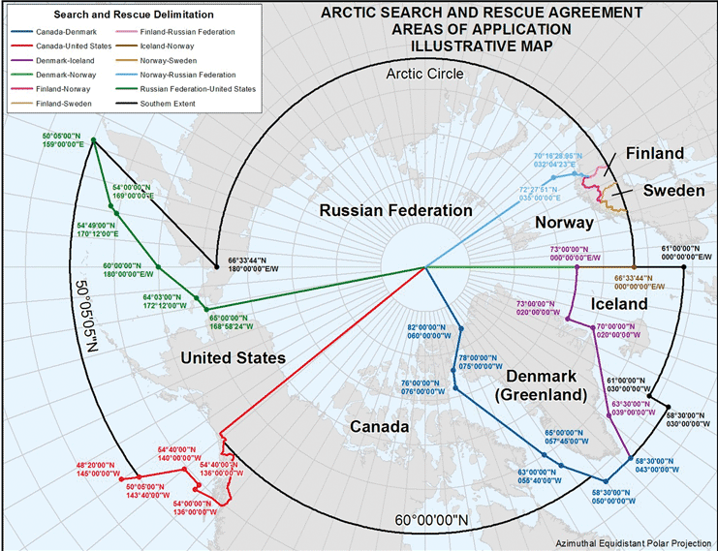

Mr. Sverre Engeness, Head of the Norwegian Coast Guard, will introduce the Committee to the work and challenges of the Norwegian Coast Guard, and the status of the Arctic Coast Guard cooperation.

Decision proposal:

The Committee takes note of the information